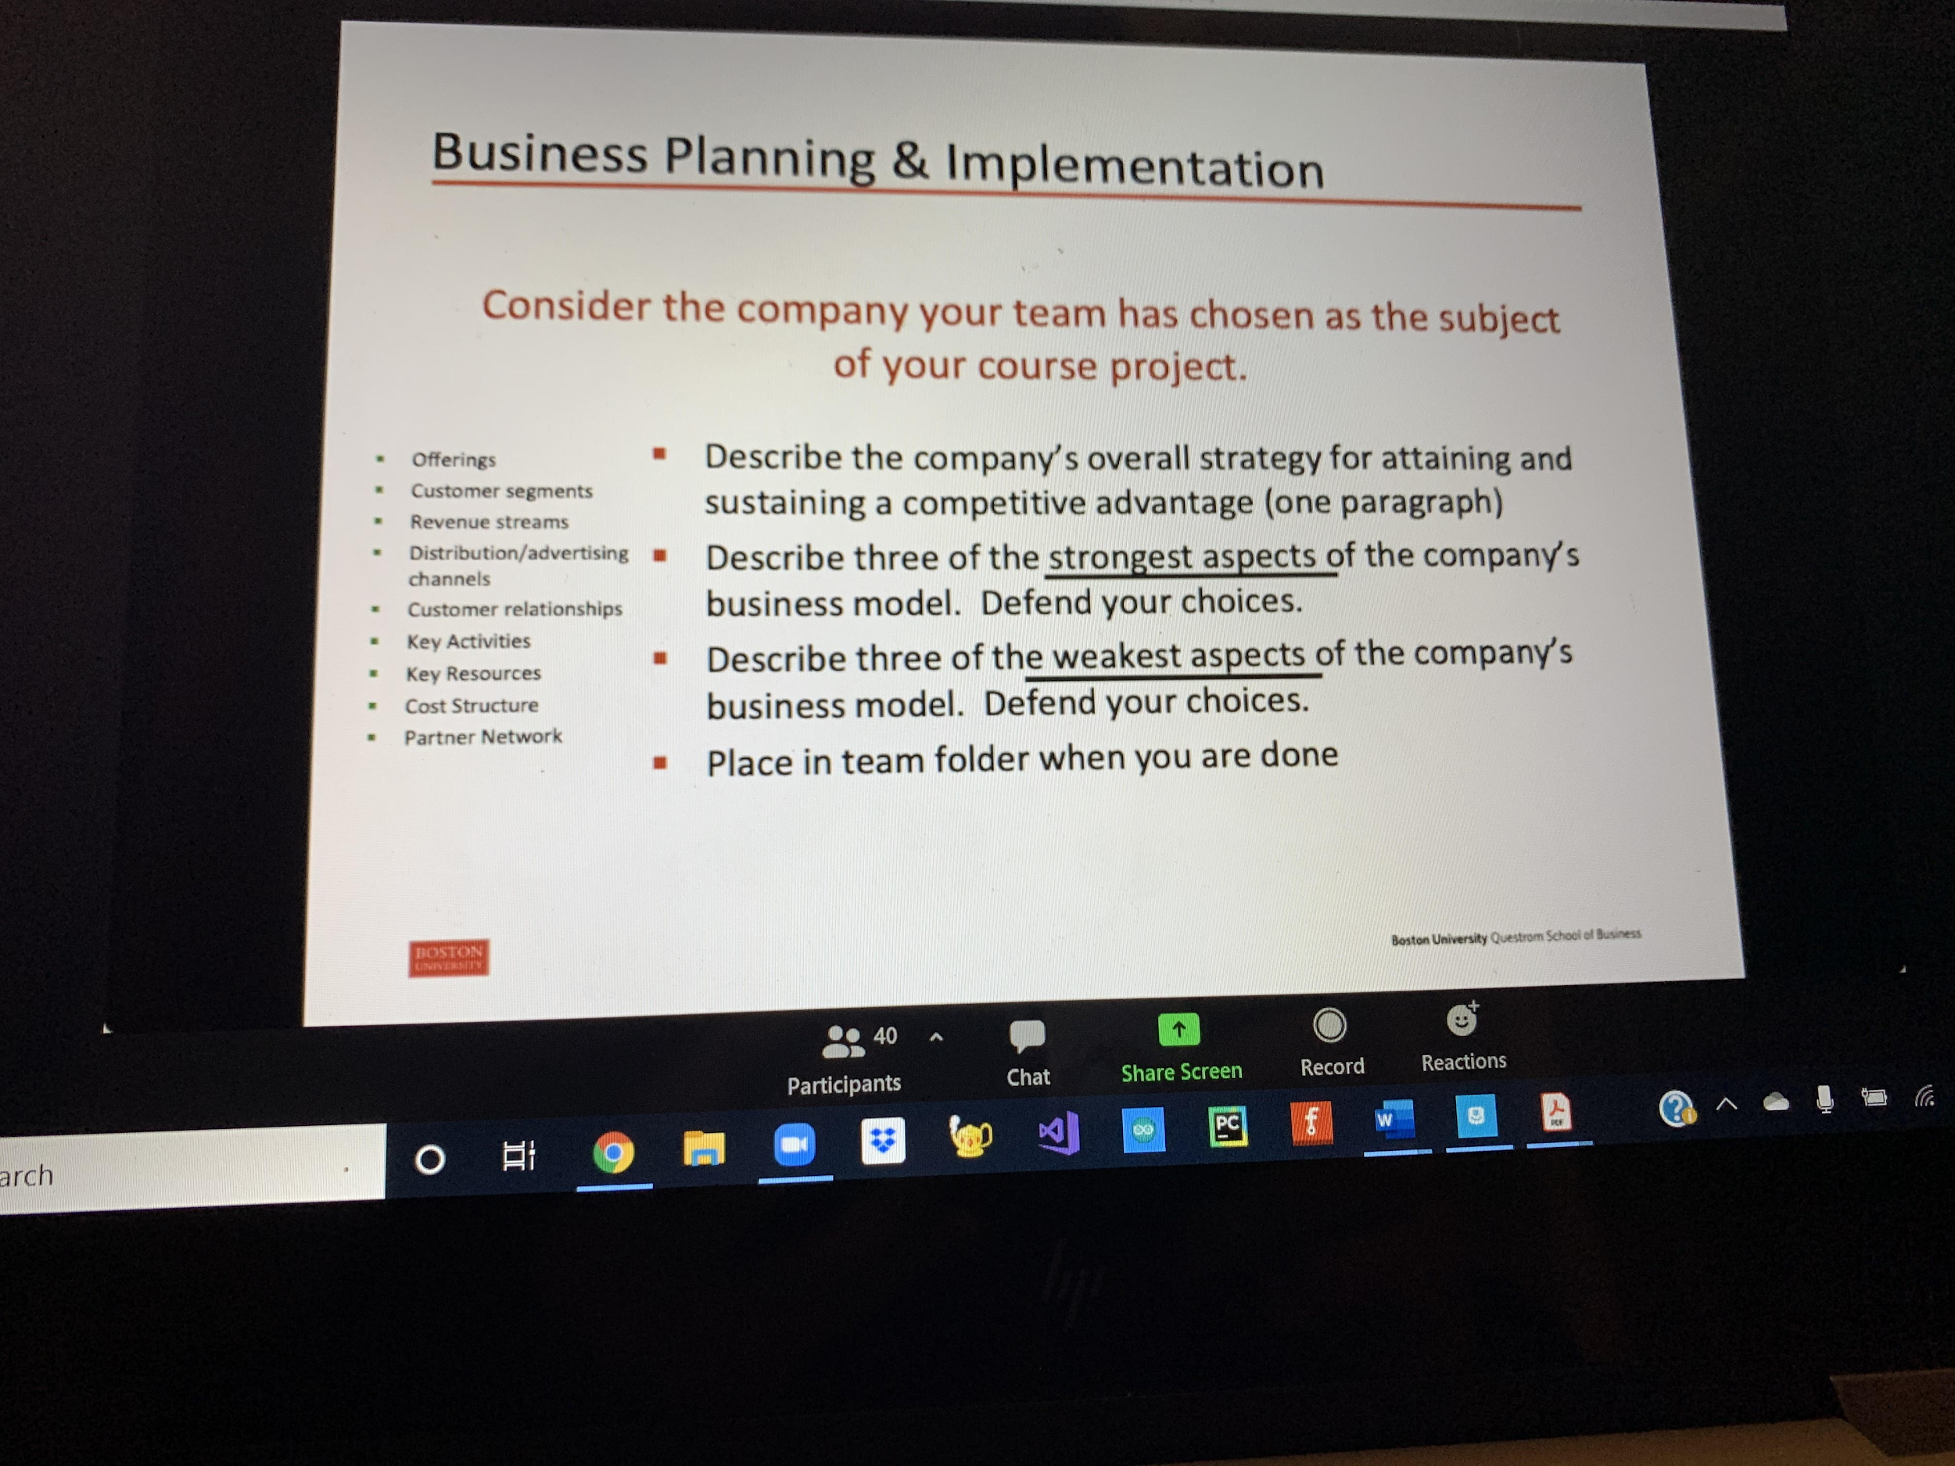

* **Describe the company’s overall strategy for attaining and sustaining a competitive advantage (one paragraph)**
  + Product differentiation
  + Disney’s unparalleled collection of IP, unique brand, and superior content monetization capabilities give it a significant competitive advantage over Netflix
  + Strong focus on innovation and creativity
  + Emphasize uniqueness in product development and widely available to all populations
  + Aggressive advertising
  + Single whole with multiple parts with integration across business units rather than operating individually - Strategy is to create, buy, and exploit “corporate franchises” such as *Mickey Mouse*, *Frozen* and *Avengers* to enhance the earnings power of multiple businesses - Forbes
* **Describe three of the strongest aspects of the company’s business model. Defend your choice.**
  + Diversified offerings and business units
  + Integration between products - can generate greater revenues while enjoying cost savings
  + Original and high quality content/products
  + Massive scope of market segments
* **Describe three of the weakest aspects of the company’s business model. Defend your choices.**
  + Decisions to invest in business unit can be challenging
  + Integrated products means failure in one line of business impacts the other lines of business